SUGAR GLIDER DIET
Natural Diet
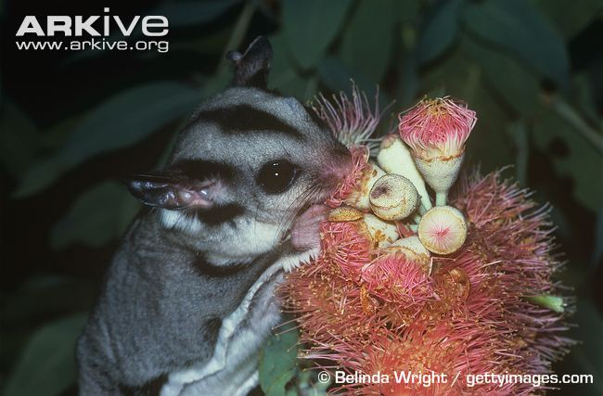
Sugar gliders are omnivorous. The diet of wild sugar gliders can include sap and gum from eucalyptus and acacia trees, nectar and pollen, manna and honeydew, and a wide variety of insects and arachnids. Sugar gliders have enlarged lower incisors for chewing into the bark of trees. The lengthened fourth digit on the hand aids in extracting insects from crevices. Sugar gliders also have an enlarged cecum (part of the large intestine) which functions primarily in microbial fermentation.
Their diet varies with the season. During the spring and summer months, these animals are primarily insectivorous. During the winter months, sugar gliders feed on gum from the eucalyptus and acacia trees, as well as on sap and sugar from the trees and sap-sucking insects.

Captive Diet
Captive diets must satisfy the numerous specializations of these omnivores. The captive diet should include nectar, insects, and other protein sources (quality pelleted diet), as well as limited amounts of fresh produce.
Protein is a critical nutrient in the diet of sugar gliders. Protein sources include insects (mealworms and crickets), eggs, newborn mice, lean meat, and commercial protein sources (sugar glider pelleted diet).
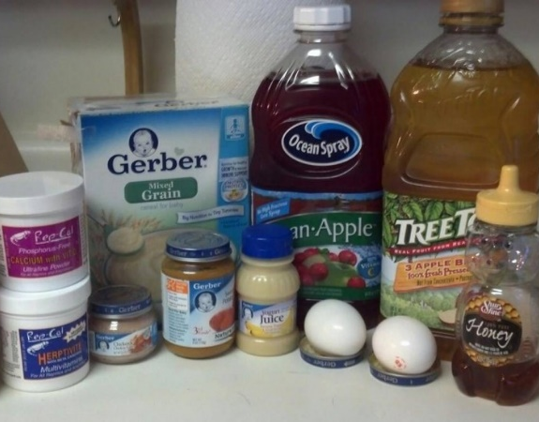
Other natural dietary components are sap and nectar, which provide necessary carbohydrates. Sources include fresh nectar, maple syrup, honey, and artificial nectar products. Examples of commercial products include prepared lory diets and Gliderade. Commercial diets should compose about 25% of the diet.
Fresh produce that is appropriate for feeding includes leafy green vegetables (e.g. kale, parsley), fruits, vegetables, nuts and seeds (e.g. sunflower, pumpkin). Fruit juices and strained baby food can be offered if they are free of preservatives. These foods should constitute less than 10% of the captive diet.
Sprinkle a broad-spectrum vitamin and mineral supplement with a good calcium supply on the food daily.
A diet that contains too much fruit will be deficient in protein and calcium. Fruit should only comprise a small fraction of the diet (less than 5%).
Simplified Diet
A breakdown of the recommended diet for captive sugar gliders is as follows:
- 45% insectivore / carnivore pelleted diet
- 45% Leadbeater’s mixture (refrigerate for up to 3 days, or freeze):
  - 150mL water
  - 150mL honey
  - One shelled hard-boiled egg
  - 25g high protein baby cereal
  - 1 tsp vitamin and calcium supplement
- Occasional (<10%) fruits, greens, vegetables, nuts, seeds, insects, and Greek yogurt
Increase the pelleted portion of the diet in growing or reproductively active animals to supply adequate protein and calcium.
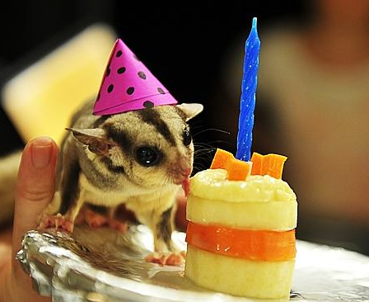
What Not to Feed
Chocolate and dairy products (excluding plain Greek yogurt) should not be fed to your pet sugar glider. Avoid foods treated with pesticides.
Fruits and vegetables known to be high in oxalates should be avoided, as they will impair calcium absorption. Those of concern include raspberries, strawberries, blackberries, spinach, carrots, beets, pears, lettuce, figs and collards. Raw corn should be fed only very occasionally, as it is very sweet as well.
Diseases of Malnutrition
Common diseases that result from an improper diet include hypocalcemia and hypoproteinemia. Hypocalcemia, or low blood levels of calcium, can result in weakness, tremors, seizures, or hind-end paresis. Hypoproteinemia, or low blood levels of protein, can result in weakness and anemia. These conditions are medical emergencies.

