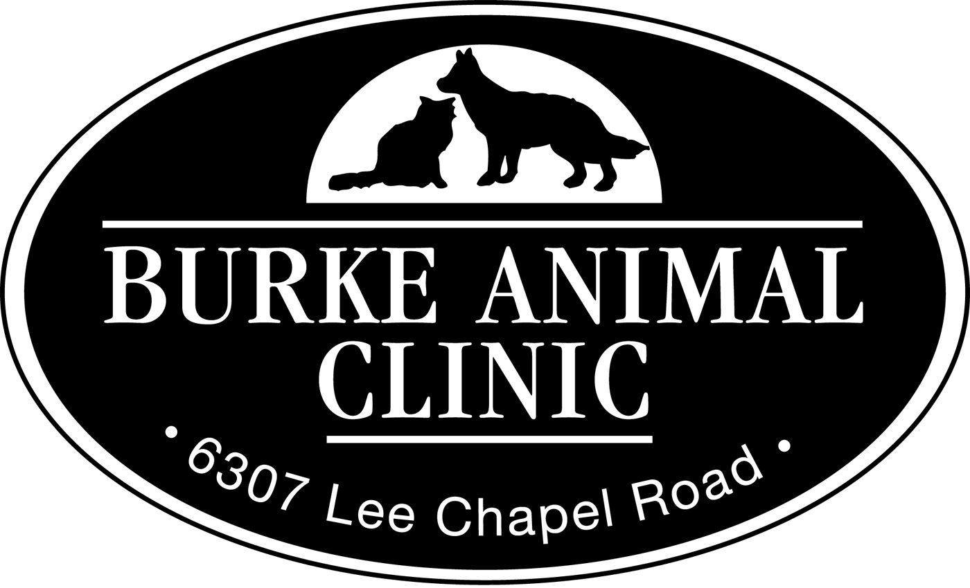Oral Health Exam, Treatment and
Discharge Time

Checked in by:
Dental Cleaning

DATE PET FILE #
OWNER TODAY’S PHONE #
I request that the doctors of Burke Animal Clinic, Ltd. perform a professional oral health exam, treatment and dental cleaning on my pet. The fee for this treatment is $386.90 and includes an oral cancer screening, digital dental x-ray (which helps diagnose dental and oral disorders), irrigation (cleaning the mouth with an antibiotic solution), hand and ultrasonic scaling and polishing, general anesthesia, IV catheter and fluids, and 1 day of hospitalization. The costs for antibiotics dispensed, pain management, fluoride treatment, additional anesthesia time and extractions are not included; these charges are assessed on an individual basis.
I grant the doctors of Burke Animal Clinic, Ltd. permission to extract decaying or diseased teeth if medically indicated (this will avoid a second anesthetic procedure to address existing problems discovered during today’s treatment). An attempt to call you will be made if extractions or treatment of periodontal pocketing is recommended. If you are unreachable a decision will be made using our best medical judgment, in your pets best interest. If the dental disease found is minimal, every attempt will be made to avoid extraction, including treating gingival pockets with medication ($49.60). The charge for extraction is $17.10-$44.60 per tooth (except “canine teeth”), depending on the number of teeth extracted and the difficulty of each extraction. Additional anesthesia may also be charged if the procedure becomes extended. Extraction of “canine teeth” is rare; costs may run between $65 and $109.80 each. If pain management is indicated as a result of the procedure, analgesics will be administered. The cost for pain management varies on a case-by-case basis based on individual patient needs to ensure comfort.
Signature Date
Some pets develop enamel decay. A fluoride treatment, that can slow this disease process, will be applied if necessary. There will be an additional charge of $ 10.40.
Signature Date
As the owner or agent of the animal named above, I hereby give my consent to Burke Animal Clinic to perform the following procedures in addition to the dental cleaning:

1. 3. 5.
2. 4. 6.
I understand that during the performance of this procedure(s), unforeseen conditions may be revealed that necessitate an extension or variance in the procedure(s) set forth above. I expect Burke Animal Clinic to use reasonable care and judgment in performing the procedure(s). The nature of the procedure and risks involved have been explained to me and I realize results cannot be guaranteed. I am also aware the unforeseen events resulting from the procedure(s) will not relieve me from any obligation to all reasonable costs incurred regarding the animal.
Signature
Please list all medications your pet has taken in the last seven days, including aspirin and all other over-the-counter anti-inflammatories:
All animals admitted must be current on their vaccinations and free of external parasites. Any animal found to have fleas or ticks will be treated at the owner’s expense.

Continued on other side
PRE-ANESTHESIA BLOOD SCREENING TEST
If your pet is 5 years of age or older and his medical procedure requires anesthesia we will perform a simple blood test beforehand to assess the function of the vital organs (i.e., kidneys and liver.). For all pets under 5 years of age we strongly recommend performing this test. Since our pets cannot alert us to problems, the test gives us valuable information to help assess your pet’s health. If the results of the blood screening show any problems with the vital organs that would cause us to delay today’s procedure, we will contact you. If the test results are normal, they are still valuable as they provide us with your pet’s baseline normal results for comparison should your pet become ill in the future.
Our policy is to routinely perform this test (CHEM 10 + CBC) on all anesthetic cases 5 years of age and older (unless a full bloodwork panel has been done within the last 30 days). The fee for the Pre-Anesthesia Blood Screening Test is $78.70.

Has pet had bloodwork in the last 30 days?
No
Yes. If so, when?

Pets 5 Years Of Age and Older (please initial)
________ I understand I will be charged $78.70 for Pre-Anesthetic blood testing should my pet require anesthesia.

Pets under 5 Years of Age (please initial)

________ YES: Please perform the Pre-Anesthetic Screen. The fee is $78.70.

________ NO: I decline the Pre-Anesthetic Screen.
OPTIONAL SERVICES: (please initial)
________ Post-operative laser therapy, if extractions are performed, to reduce inflammation, swelling and pain, and speed up healing time ($30.00)
________ Nail Trim ($10.00)
________ Microchip ($68.60)

FINANCIAL AGREEMENT

Request for service…Authorization for Examination
and medical treatment…financial responsibility

I am the owner or agent for the owner of the pet(s) described on the form and have the authority to execute this consent. I request that the veterinarians, agents, and employees of Burke Animal Clinic, Ltd., provide the services described and identified on this form.

I authorize the veterinarians on duty (and assistants they may designate) to examine the pet(s) and to administer medical treatment or emergency surgical procedure which is considered therapeutically and/or diagnostically necessary on the basis of the findings during the course of the examination. Therefore, I hereby consent to and authorize the performance of such procedure(s) as are necessary and described in the exercise of the veterinarian’s professional judgment.

I understand that any pet(s) found to be infected with either external or internal parasites will be treated for it at my expense.

I understand that the treatment of the pet(s) will be conducted with due care and in accordance with the prevailing standards of competence in veterinary medicine. I certify that no guarantee or assurance has been made as to the results that may be obtained through the course of treatment undertaken by the veterinarians, agents, or employees of Burke Animal Clinic, Ltd. I understand that a written estimate of charges is available within reasonable time of my request. I also consent to the release of medical information.

In order to help keep costs down and to continue to provide the highest quality of veterinary medicine, we require payment in full at the time services are rendered. For your convenience, we accept Cash, Visa, Mastercard, Care Credit, and Checks (with appropriate I.D.). If for any reason a portion of the balance remains unpaid at the time of service, the client agrees to pay a five-dollar processing fee that will be assessed monthly. In the event that a client defaults on payment, the client also agrees to pay all costs (including but not limited to collection and/or reasonable attorney’s fees, court costs, and any other fees or costs that occur during normal collection procedures).

I assume financial responsibility for all charges incurred to the patient services rendered and understand that full payment is required upon completion.

Pet’s Name Phone #

Signature Date

