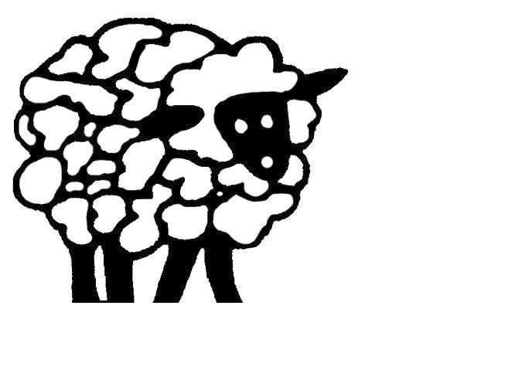
Sheep Draw Veterinary Hospital
Roger Klingenberg, DVM
Malinda Dosch, DVM
Merideth Early, DVM
Jordan Dewing , DVM
Bridget Edgren, DVM
Heather Dahl, DVM

BOARDING CHECK IN

Client Name: ___________________________________________ Date In: ________ Date Out: _________

Requirements:
All canines must be up-to-date on all vaccines, including Rabies, DHPP, Bordetella, Leptospirosis, Influenza, fecal exam, and have a current physical exam with Sheep Draw. All felines must be up-to-date on Rabies, FVRCP, fecal exam, and have a current physical exam with Sheep Draw. All reptiles and pocket pets must have a current physical exam. If any patient is not current with our requirements those services will be provided at the owner’s expense.

We reserve the right to refuse to accept a pet at check in for any reason including, without limitation, if the pet appears to be sick, injured, in pain, or that its behavior could jeopardize the health or safety of other pets or our staff.

PLEASE REVIEW AND INITIAL THE FOLLOWING:

⃰ I understand that there are certain risks of illness or injuries with boarding my pet(s) such as but are not limited to: upper respiratory infection, diarrhea, surface wounds, and torn toenails. ___________

* In the unlikely event that my pet should expire while boarding, Sheep Draw Veterinary Hospital will retain the body until such time as I return or other arrangements can be made.____________

⃰ For pets requiring medication(s)/supplements there is an additional fee of $2.50/day. For pets requiring insulin injections there is a fee of $5.00/day.____________

⃰ Medical Illness Policy (Please Check One): One of the advantages of boarding your pet(s) at a veterinary hospital is that veterinary attention is readily available should the need arise. If your pet(s) becomes ill, we will call the emergency number listed below regarding your pet(s) symptoms, treatment options, and estimate of additional costs. If a medical emergency should arise, all reasonable treatments will be made prior to contacting your emergency contact to stabilize your pet. If no one can be reached, please indicate your wishes below should your pet(s) require treatment to relieve immediate discomfort and/or to resolve an important medical condition.
Please choose one:
_______Please perform whatever services the doctor deems necessary for the best care of my pet
until someone can be reached. This includes only non-elective treatments and any necessary diagnostics at any expense.
_______I authorize up to (check one): ____$100 ____$250 ____ Other; $ ________
_______Do not administer any medical treatment until specific authorization is given.

Your pet’s boarding rate is $________ per pet/day which brings the boarding total to $ /day. This does not include any additional cost that may arise during the pets boarding stay. As a convenience we are open for boarding pick up on Sunday from 5-6pm (excluding holidays). This day is charged as a full day. I fully intend to pick up my pet on or around the above date specified. If circumstances change, I will notify the veterinary clinic of a new pick up date. I understand that I am responsible for these charges and that payment is due, in full, upon discharge of my pet.

Emergency Contact Information Name: _______________________________Phone: __________________

● We feed Royal Canin GI. If your pet requires special food, please provide.

Feeding Guidelines:

Pet: __________ Pet: __________ Pet: __________

□ Own Food □ Own Food □ Own Food □ Royal Canin □ Royal Canin □ Royal Canin

Amount: __________ Amount: __________ Amount: __________
Frequency: ________ Frequency: ________ Frequency: ________

Medications:

Pet: __________ Pet:__________ Pet: _________

Med: ____________ Med: ___________ Med: ___________

Freq: ____________ Freq: ___________ Freq: ___________

Med: ____________ Med: ___________ Med: ___________

Freq: ____________ Freq: ___________ Freq: ___________

When was the last time your pet had food/medication? _________________________________

Allergies:

Does your pet have any known food allergies? If so, please list: __________________________
For enrichment, can we use treats/peanut butter? □ Yes □ No
Are there any special instructions we need to know about? ______________________________
______________________________________________________________________________

Personal Belongings:

□ Bowl(s) □Blanket(s) □ Bed(s) □ Carriers □Clothing

□ Leash □ Harness □ Toys □ Treats □ Bones

□ Other: _____________

° If your pet’s stay is longer than amount of food provided, we will feed Royal Canin.
OFFICE USE ONLY

Pet: _________ Pet: _________ Pet: _________ Pet: _________
Kennel Size: _________ _________ _________ _________

Does the pet need:

DA2PL-CPV _________ _________ _________ _________
Bordetella _________ _________ _________ _________
Lepto _________ _________ _________ _________
H3N2 _________ _________ _________ _________
Rabies _________ _________ _________ _________
FVRCP-P _________ _________ _________ _________
Leukemia _________ _________ _________ _________
Fecal _________ _________ _________ _________

Does the pet(s) require any other services?

□ Nail trim
Pets name(s) ___________________________________

□Anal Gland Expression
Pets name(s) ___________________________________

□ Medical Procedure ____________
Pets name(s) ___________________________________

□ Other: _____________
Pets name(s) ___________________________________

These services are offered at an additional charge to the owner.

